Introduction to PPO and Its Application in a Drug-Concentration Control Simulation
- Introduction
With the rapid advancement of artificial intelligence, reinforcement learning (RL) has emerged as a powerful framework for solving complex sequential decision-making problems.¹⁻³ Unlike supervised learning, which relies on labelled data, RL enables an agent to learn optimal behaviours through continuous interaction with an environment, gradually improving its performance via trial and error. ⁴ This paradigm has demonstrated remarkable potential in domains such as robotics, autonomous navigation, medical decision support, energy optimisation, and large-scale infrastructure control. ⁵
RL addresses several key challenges that traditional control or optimisation methods struggle with. First, many real-world environments are dynamic and uncertain, requiring adaptive strategies rather than fixed rules. Second, optimal solutions must balance short-term actions with long-term consequences, which classical algorithms often fail to handle effectively. Third, complex systems—such as biological processes, robotics, and environmental networks—often have large or continuous action spaces, making exhaustive search or manual tuning infeasible. ⁶ RL provides a systematic way to learn policies in such settings, even when explicit system models are unavailable
- Theoretical Explanation
Despite promising capabilities of traditional RL methods, it still face two major challenges when applied to real-world systems: 1.unstable training dynamics, where overly aggressive policy updates can cause catastrophic drops in performance; 2.difficulties in handling high-dimensional continuous action spaces, which are common in control tasks such as robotic manipulation or drug infusion rate optimisation. ⁷ To address these challenges, OpenAI introduced the Proximal Policy Optimization (PPO) algorithm in 2017. The core idea of PPO is to improve policy gradient methods by restricting the magnitude of each policy update, ensuring that the policy evolves steadily rather than abruptly. This is achieved through a clipped surrogate objective, which prevents excessively large updates that could destabilise training. ⁸ By enforcing such proximity constraints, PPO strikes a practical balance between learning efficiency and robustness.
Owing to its stability, ease of implementation, and strong empirical performance, PPO has become one of the most widely adopted algorithms in modern RL research and applications. It has been successfully used in 1.robotic motion and trajectory control; 2.autonomous aerial vehicle navigation; 3.locomotion and balance learning in simulated agents; 4.medical treatment and drug infusion regulation; 5.urban systems optimization, including energy distribution and wastewater management. ^{9,10}
These applications demonstrate that PPO provides a general, reliable, and scalable solution for continuous control problems, enabling reinforcement learning algorithms to transition from game-based benchmarks to real scientific and engineering systems. Here we explain the key mechanisms of PPO using essential mathematical components, without detailed derivations.
2.1. Probability Ratio
PPO evaluates policy updates by comparing the new and old action probabilities. This ratio measures how much the new policy changes its preference for action:
$$r_{t}\left(θ\right)=\frac{π_{θ}(a_{t}|s_{t})}{π_{θold}(a_{t}|s_{t})}$$
2.2. Advantage Function
The quality of action is measured using the advantage: A positive means the action is better than expected; negative means worse:
$$A_{t}=Q\left(s_{t},a_{t}\right)-V(s_{t})$$
2.3. Clipped Objective
This clipping mechanism is the main innovation of PPO:
$$L^{CLIP}\left(θ\right)=E[min⁡(r_{t}A_{t}, clip(r_{t},1-∈,1+∈)A_{t})]$$
PPO allows policy updates, but if the update becomes too large, PPO automatically clips it. This prevents harmful, unstable updates, ensuring training remains smooth and robust.

- Code Demonstration
This section presents a simplified PPO implementation applied to a virtual environment that simulates drug-concentration regulation inside a blood vessel. The environment is intentionally minimal, mirroring the structure of a drainage-network chemical-concentration control problem while keeping the code focused on PPO’s core logic.
  - Env
A simplified blood vessel model where the state is current drug concentration, actions are injection amounts, and the goal is to maintain concentration near a target.
class DrugVesselEnv(gym.Env):
def step(self, action):
injection = float(action[0])
conc = self.decay * self.state + 0.1 * injection
self.state = conc
reward = -abs(conc - self.target) - 0.05 * (injection**2)
done = False
return self.state, reward, done
  - PPO Agent:
A Proximal Policy Optimization agent using a neural network to learn a policy that selects injection actions, with clipping to stabilize updates.
class Policy(nn.Module):
def __init__(self):
super().__init__()
self.net = nn.Sequential(nn.Linear(1,32), nn.ReLU(), nn.Linear(32,32), nn.ReLU())
self.mu = nn.Linear(32,1)
self.log_std = nn.Parameter(torch.zeros(1))
def forward(self, x):
x = self.net(x)
return self.mu(x), self.log_std.exp()
class PPOAgent:
def __init__(self, lr=1e-3, eps=0.2):
self.policy = Policy()
self.optimizer = optim.Adam(self.policy.parameters(), lr=lr)
self.eps = eps

  - Training Loop
The agent interacts with the environment to collect states, actions, and rewards, computes advantages, and updates the policy iteratively while tracking performance and concentration over time.
env = DrugVesselEnv()
agent = PPOAgent()
episodes = 100
time_steps = 50
The complete code can be found at https://github.com/Venuseofme/RL-Bioengineering.git
- Results and Visualisation
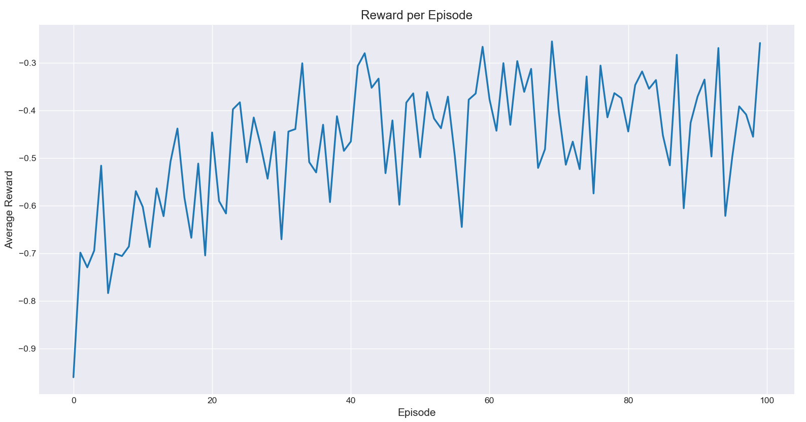
Figure 1. Average Reward per Episode
Figure 1 shows the average reward per episode during training. Initially, the reward is around -1 due to the agent’s random policy and large deviation from the target concentration. As training progresses, the PPO agent gradually learns to adjust injection amounts to maintain blood concentration near the target, and the average reward stabilizes around -0.4. This upward trend indicates effective policy learning.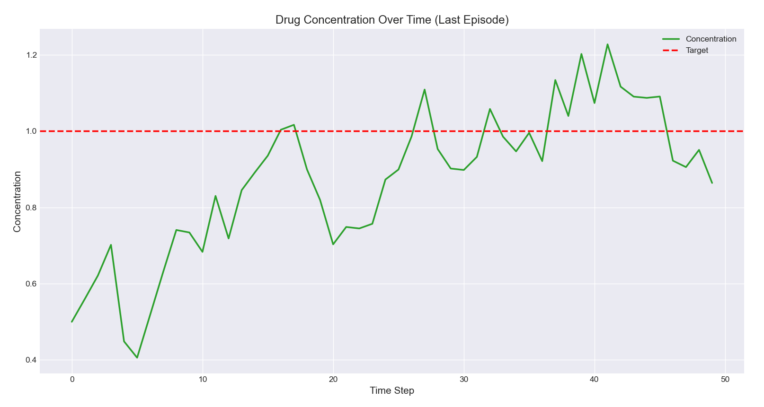
Figure 2. Blood Concentration Over Time (Last Episode)
Figure 2 illustrates the blood concentration over time in the last training episode. Early time steps may show fluctuations, but later the concentration stabilizes around the target value (red dashed line). The smoothness and closeness to the target demonstrate that the agent has learned a reasonable injection policy, achieving stable control of the desired blood concentration.
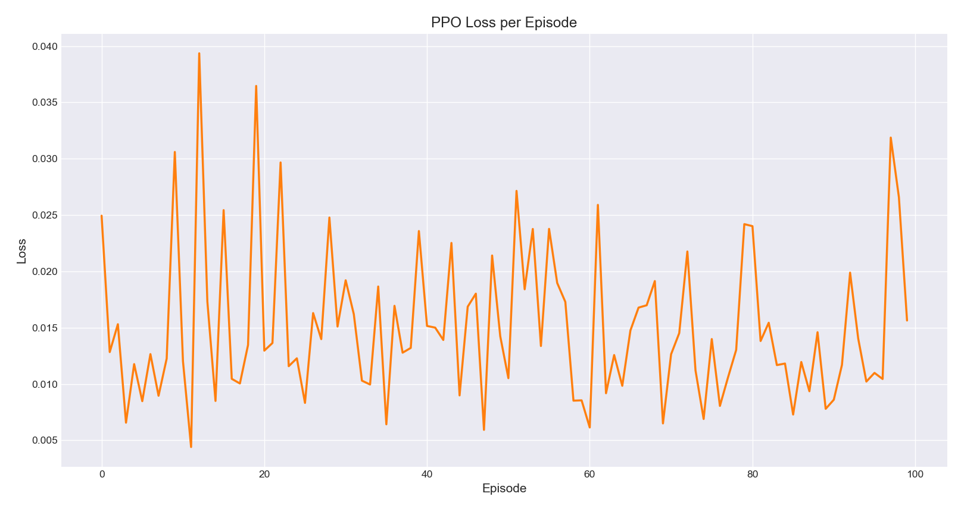
Figure 3. PPO Loss per Episode
Figure 3 depicts the PPO loss per episode. Unlike the reward curve, the loss does not decrease monotonically. Instead, it exhibits high fluctuations: some episodes show very high loss values, while others remain closer to normal levels. This behavior reflects the inherent variability in policy updates during PPO training, as the clipping mechanism and stochastic sampling can cause occasional spikes. These fluctuations are likely caused by the stochastic nature of PPO updates, including 1.Mini-batch sampling variability: Each policy update uses a subset of experiences, which can produce varying gradient magnitudes; 2.Clipping in the PPO objective: The clipping mechanism prevents large policy updates, but can occasionally lead to abrupt changes in loss values depending on advantage estimates; 3.Sparse or noisy rewards in some episodes: Small deviations in blood concentration can result in large negative rewards, temporarily increasing loss.
- Bioengineering Contextualisation
Reinforcement learning, particularly PPO, has great potential in bioengineering applications that require adaptive, real-time control. In this tutorial, we demonstrated PPO for regulating blood drug concentration in a simplified digital environment. This approach can be extended to real-world personalized drug delivery systems, where the goal is to maintain therapeutic drug levels within a patient’s bloodstream while minimizing side effects. For instance, an RL agent could continuously adjust infusion rates in response to real-time sensor measurements, adapting to individual patient metabolism, circadian variations, or other physiological changes.
Beyond drug delivery, PPO and other RL methods could also be applied to robotic prosthetics: Adaptive control for movement assistance based on real-time biomechanical feedback. Rehabilitation robotics: Adjust exercise intensity or support in response to patient progress. Synthetic biology: Regulate gene expression or metabolic pathways in microbial cultures for optimized production. In summary, the PPO algorithm’s ability to learn robust policies in continuous, dynamic environments makes it a promising tool for adaptive, personalized bioengineering solutions that require real-time decision-making.

I acknowledge the use of ChatGPT 5 (OpenAI, https://chat.openai.com/) to generate an outline for background study. I confirm that no content generated by AI has been presented as my own work
- References
[1] Wang, X., Ma, Z., Cao, L. et al. A planar tracking strategy based on multiple-interpretable improved PPO algorithm with few-shot technique. Sci Rep 14, 3910 (2024). https://doi.org/10.1038/s41598-024-54268-6
[2] de Miguel Gomez, A. and Toosi, F. G. (2021). Continuous Parameter Control in Genetic Algorithms using Policy Gradient Reinforcement Learning. In Proceedings of the 13th International Joint Conference on Computational Intelligence (IJCCI 2021) - ECTA; ISBN 978-989-758-534-0; ISSN 2184-3236, SciTePress, pages 115-122. DOI: 10.5220/0010643500003063
[3] Kargin, T.C., Kołota, J. A Reinforcement Learning Approach for Continuum Robot Control. J Intell Robot Syst 109, 77 (2023). https://doi.org/10.1007/s10846-023-02003-0
[4] D. Adamu Aliyu, E. Akashah Patah Akhir, M. Omar Abdullah Sawad, J. Shehu Yalli and Y. Saidu, "A Reinforcement Learning Approach to Personalized Asthma Exacerbation Prediction Using Proximal Policy Optimization," in IEEE Access, vol. 13, pp. 103373-103384, 2025, doi: 10.1109/ACCESS.2025.3579198.
[5] C. -H. Cho, P. -J. Huang, M. -C. Chen and C. -W. Lin, "Closed-Loop Deep Brain Stimulation With Reinforcement Learning and Neural Simulation," in IEEE Transactions on Neural Systems and Rehabilitation Engineering, vol. 32, pp. 3615-3624, 2024, doi: 10.1109/TNSRE.2024.3465243.
[6] D. F. G. Filho, M. A. Moret and E. G. S. Nascimento, "A Custom Reinforcement Learning Environment for Hybrid Renewable Energy Systems: Design and Implementation," in IEEE Access, vol. 13, pp. 133984-133993, 2025, doi: 10.1109/ACCESS.2025.3593064.
[7] Tan, C.; Wang, J.; Cai, H.; Hu, S.; Zhang, B.; Zhu, W. Phase-Adaptive Reinforcement Learning for Self-Tuning PID Control of Cruise Missiles. Aerospace 2025, 12, 849. https://doi.org/10.3390/aerospace12090849
[8] Jifei Deng, Seppo Sierla, Jie Sun, Valeriy Vyatkin, Reinforcement learning for industrial process control: A case study in flatness control in steel industry, Computers in Industry, 143, 2022, 103748, ISSN 0166-3615, https://doi.org/10.1016/j.compind.2022.103748.
[9] Garcia, C. (2024). Reinforcement learning for dynamic pricing and capacity allocation in monetized customer wait-skipping services. Journal of Business Analytics, 8(1), 36–54. https://doi.org/10.1080/2573234X.2024.2424542
[10] F. Rahimi Ghashghaei, N. Elmrabit, A. -U. -H. Qureshi, A. Akhunzada and M. Yousefi, "Advanced Quantum Control With Ensemble Reinforcement Learning: A Case Study on the XY Spin Chain," in IEEE Access, vol. 13, pp. 49514-49526, 2025, doi: 10.1109/ACCESS.2025.3551232

